**OS Assignment No. :1**

**Name**: Akash Bhadane

**Problem 1: Read the instructions carefully and answer accordingly. If there is any need to insert some data, then do that as well.**

**Answers:**

**a) Navigate and List :**

* cd ~
* ls
* mkdir -p LinuxAssignment
* cd LinuxAssignment

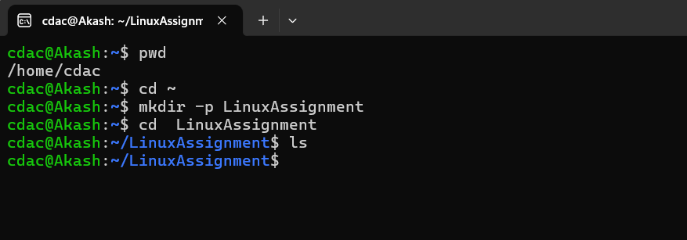

**b) File Management:**

* touch file1.txt
* cat file1.txt

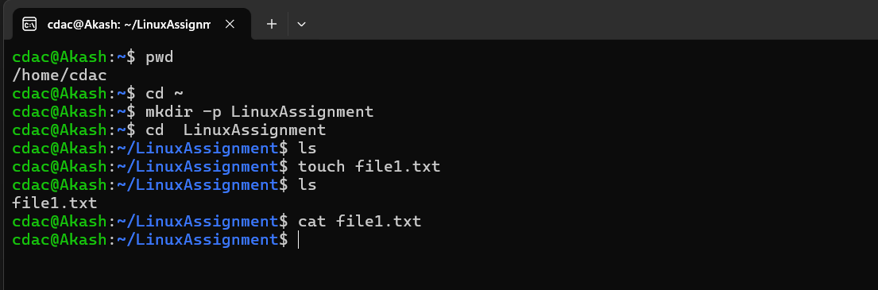

**c) Directory Management:**

* mkdir docs

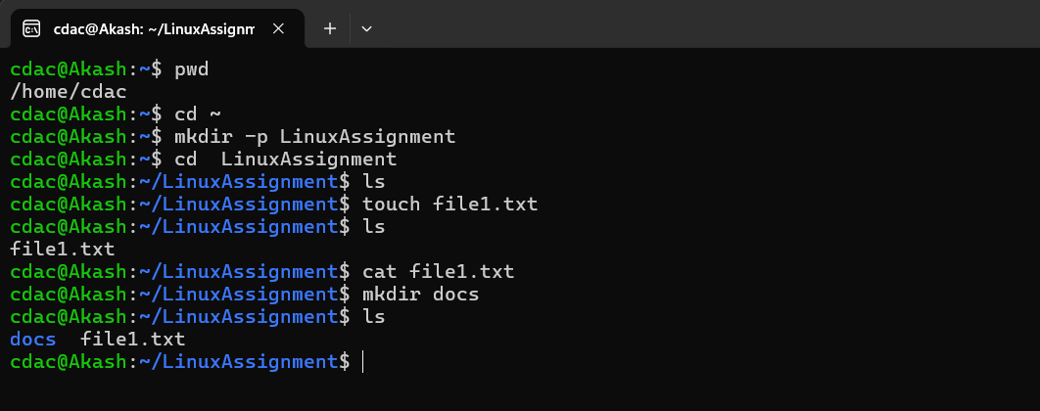

**d) Copy and Move Files:**

* cp file1.txt docs/file2.txt

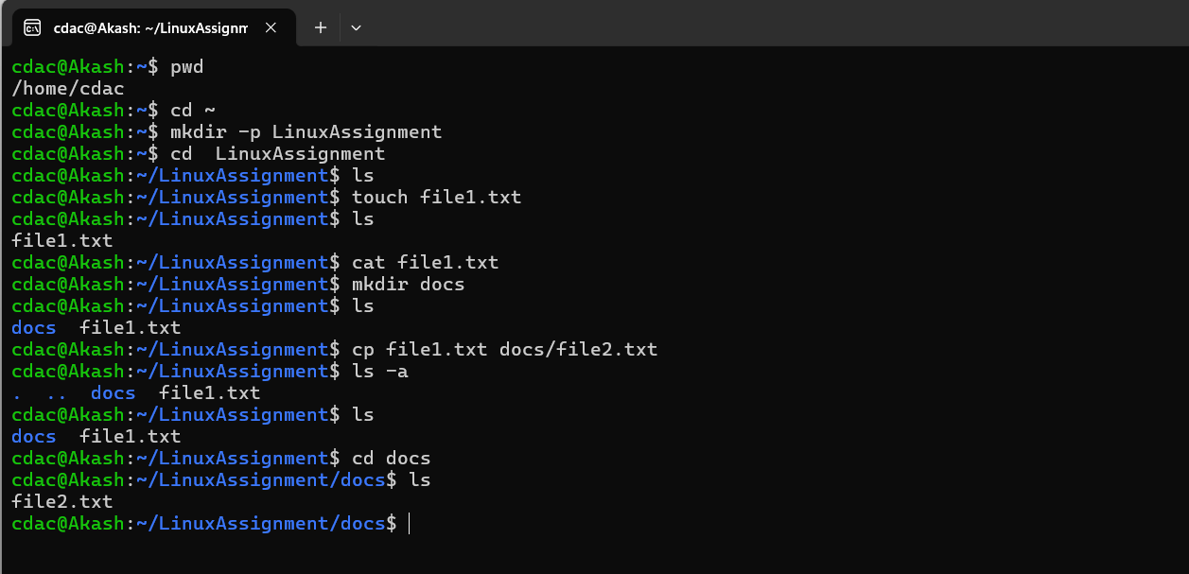

**e) Permissions and Ownership:**

* chmod u=rwx,o=r file2.txt
* ls -l file2.txt

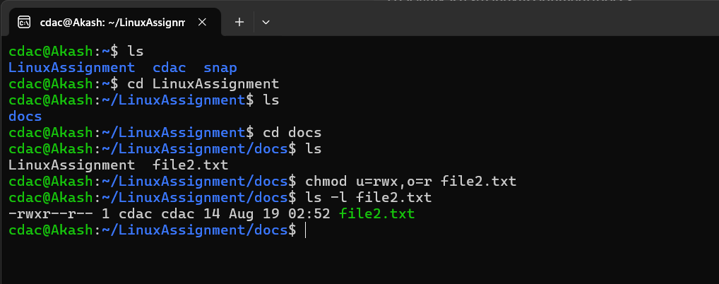

**f) Final Checklist:**

* ls LinuxAssignment
* ls /

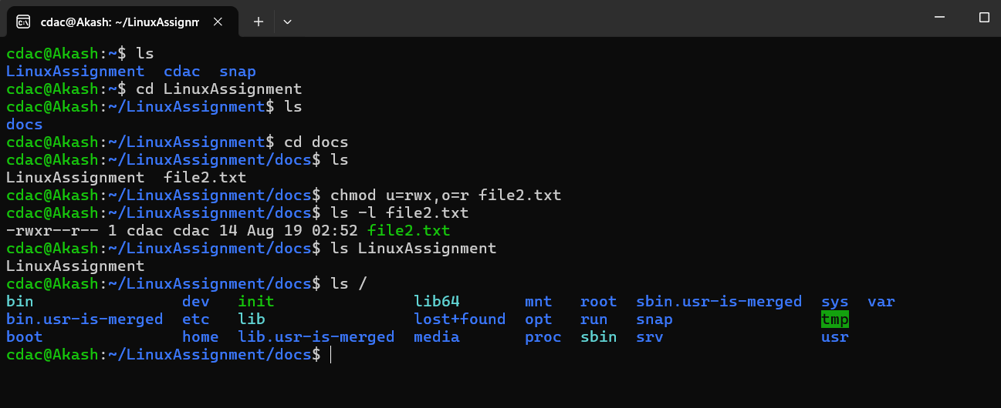

**g) File Searching:**

**a)**

* find . -name "*.txt" or ls *.txt

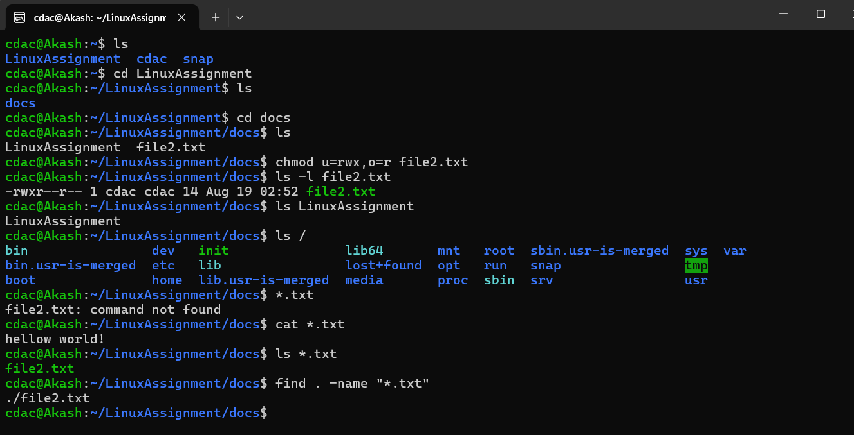

**b)** grep “html” file2.txtt

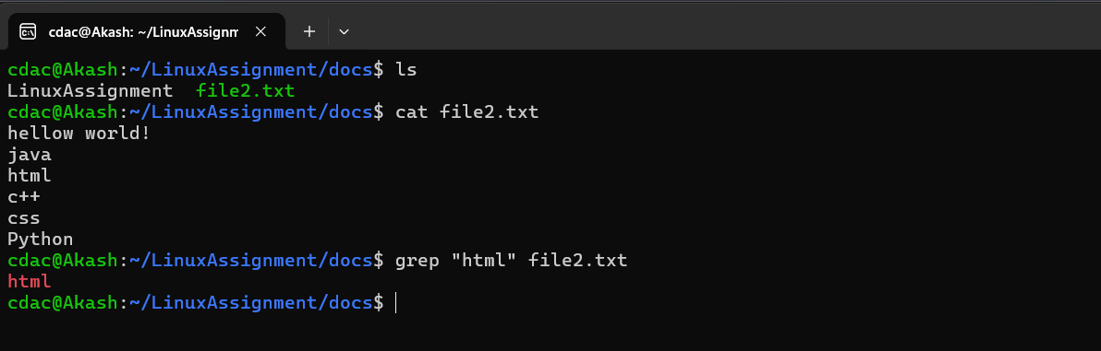

**h) System Information:**

* date

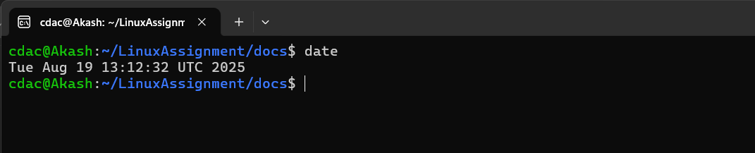

**i) Networking:**

**a)** hostname - I

**cdac@Akash:~$ 182.15.70.180**

**b)** ping google.com

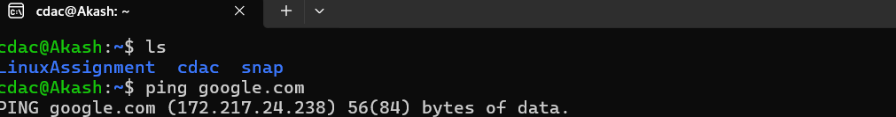

**j) File Compression: a)**

* zip -r docs.zip docs

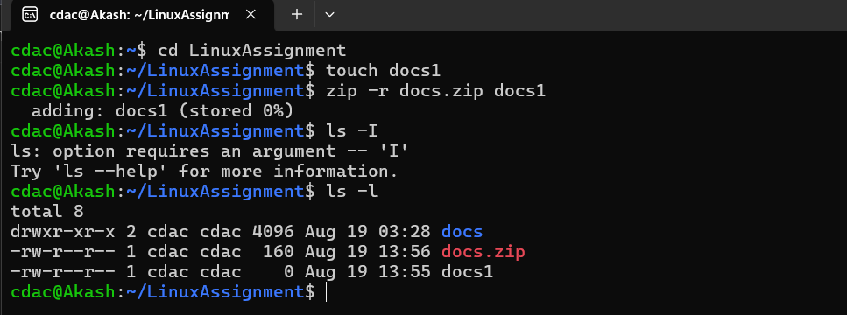

**b)**

* unzip docs.zip -d docs

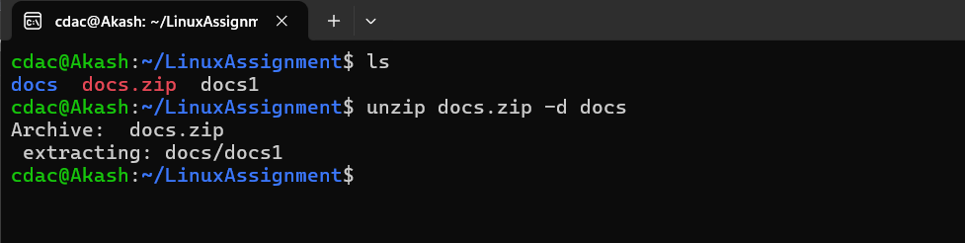

**k) File Editing: a)**

* vi file1.txt
* cat file1.txt

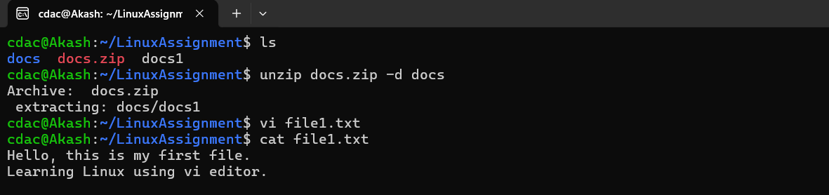

**b)**

* sed -i 's/c++/spring/g' file2.txt
* cat file2.txt

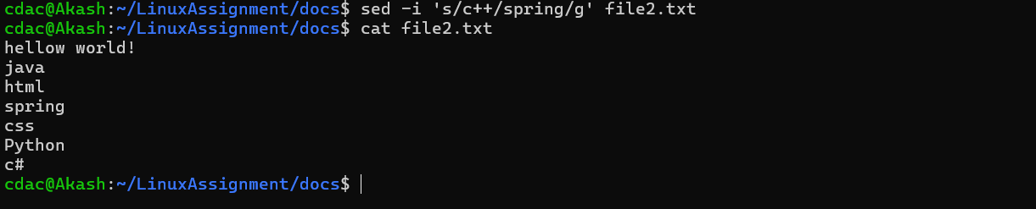

**Problem 2: Read the instructions carefully and answer accordingly. If there is any need to insert some data then do that as well.**

* head -n 10 data.txt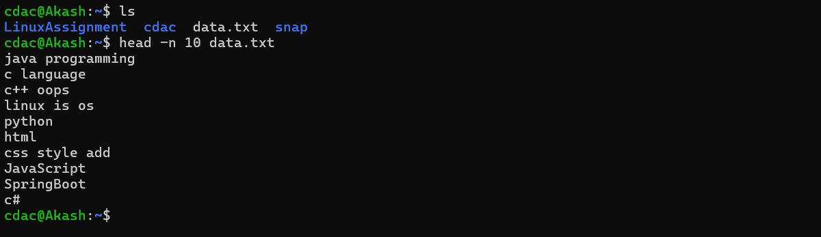
* 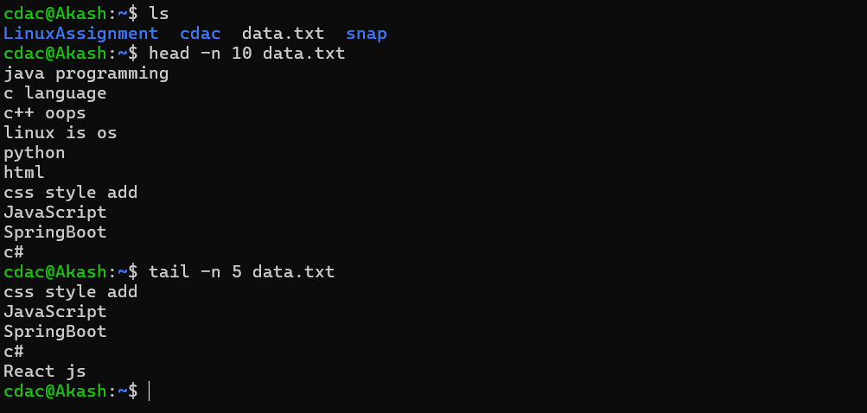 tail -n 5 data.txt

**c)**

* head -n 15 numbers.txt

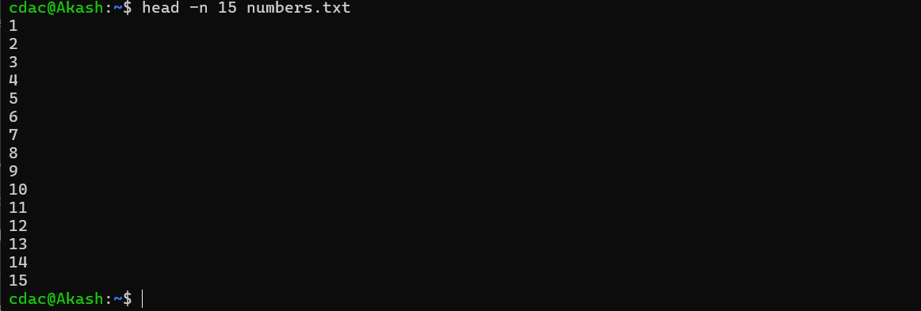

**d)**

* tail -n -3 numbers.txt

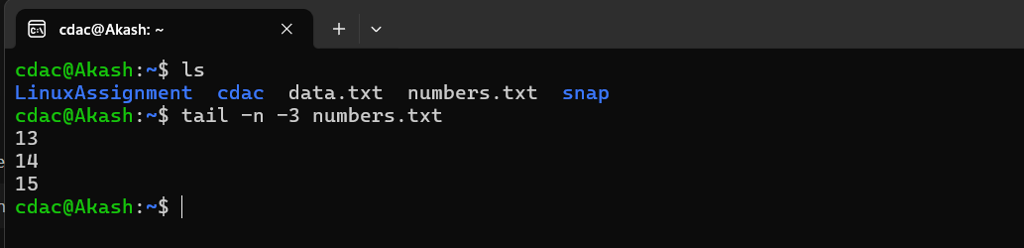

**e)**

* tr 'a-z' 'A-Z' < input.txt > output.txt

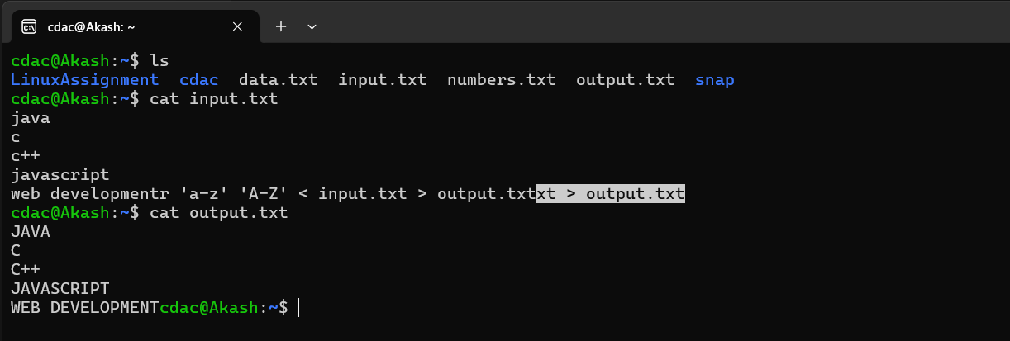

**f)**

* sort duplicate.txt | uniq

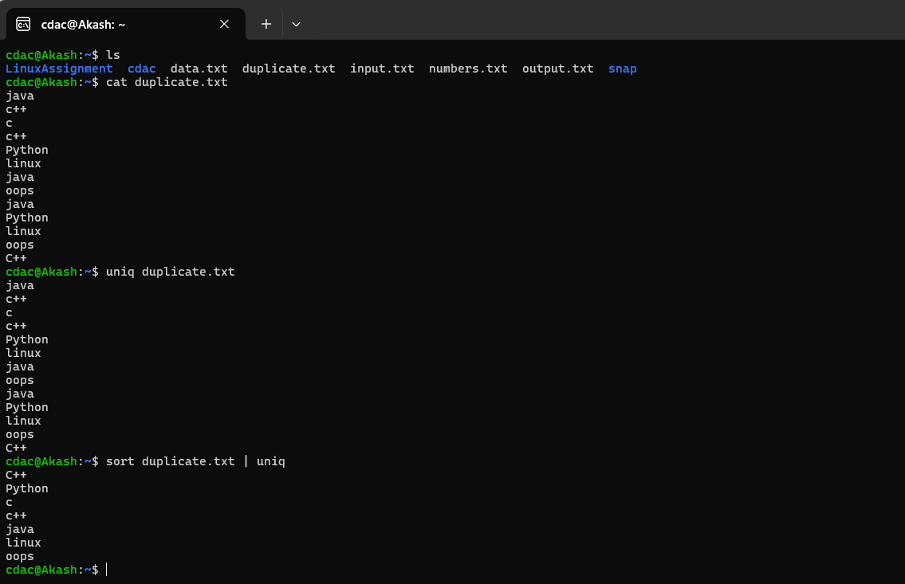

**g)**

* cat >> fruits.txt
* cat fruits.txt
* sort fruits.txt | uniq -c

